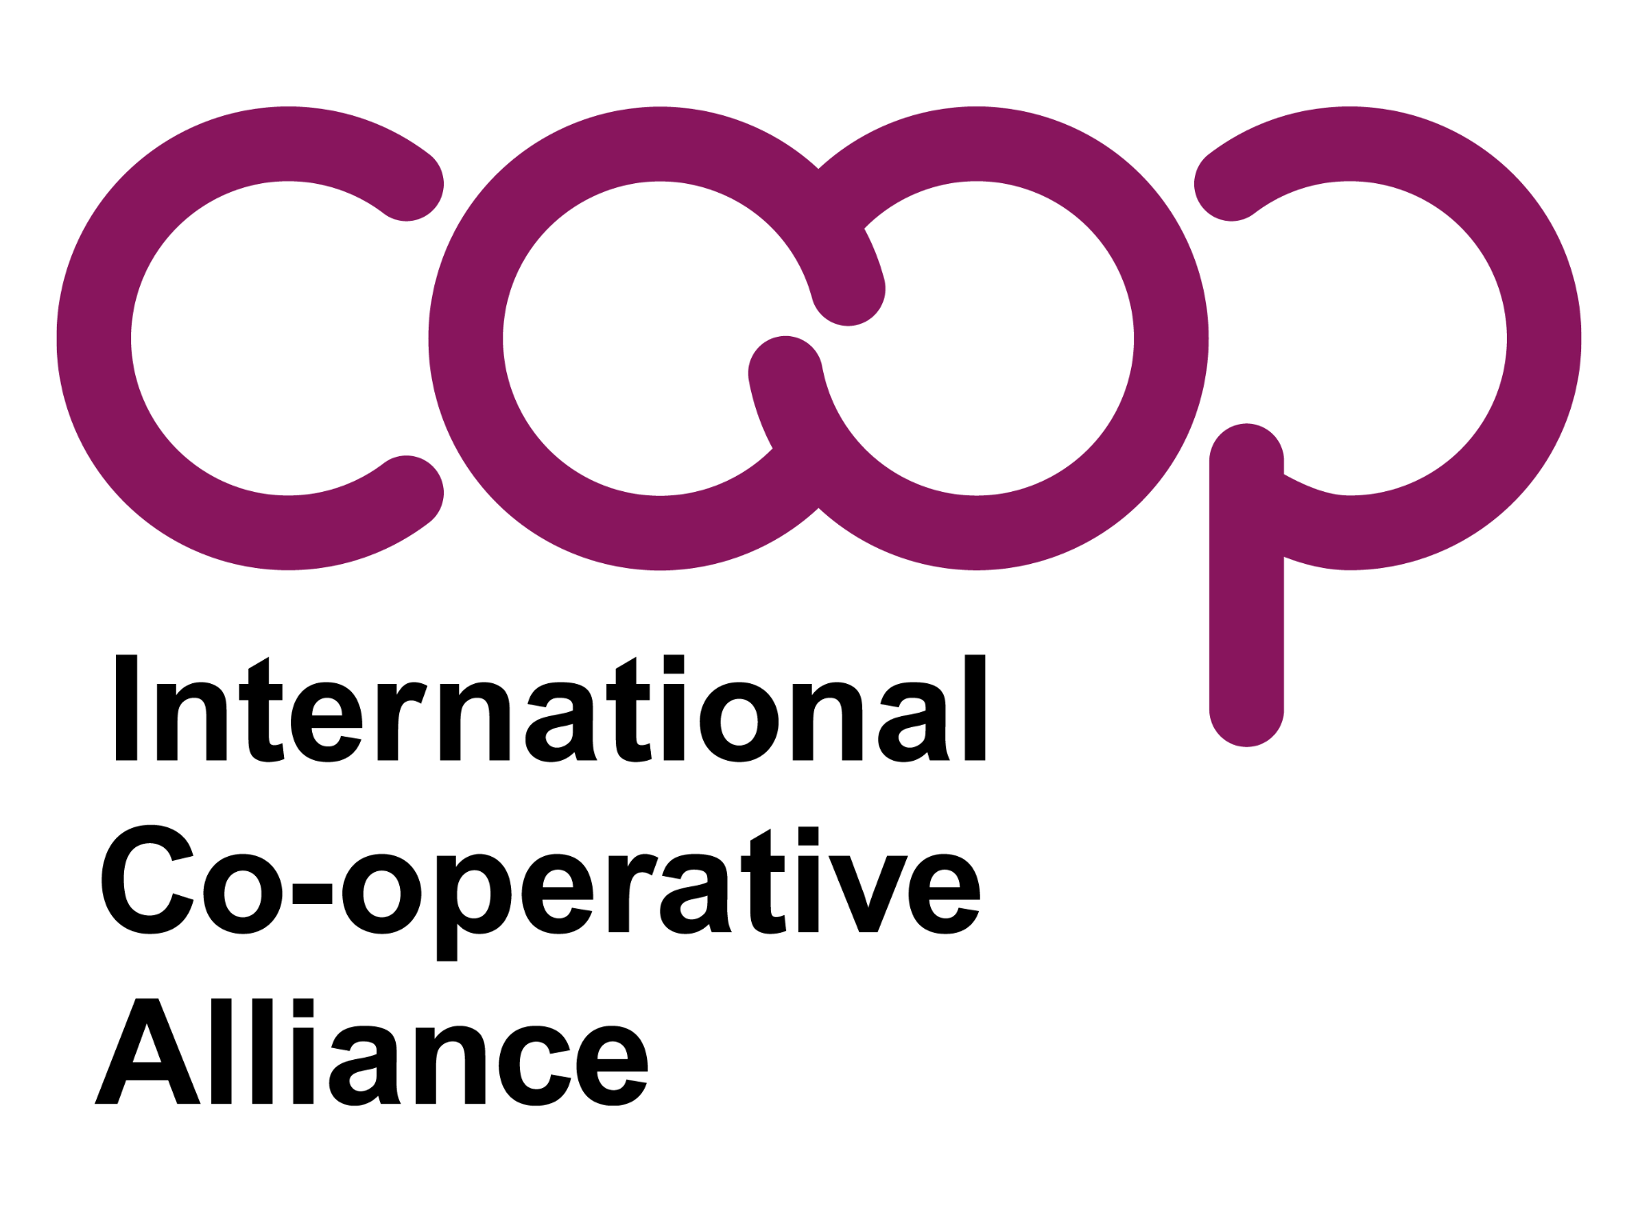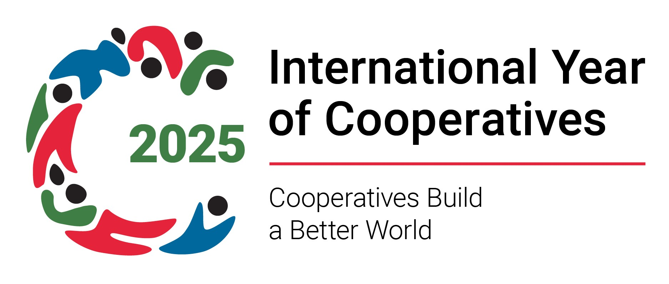

International Cooperative House, avenue Milcamps 105, 1030 Brussels - Tel: +32 (2) 743 10 30 - ica@ica.coop - www.ica.coop - Twitter: @icacoop

PRESS RELEASE

International Cooperative Alliance 2026-2030 strategy commits to ‘Practice, Promote and Protect’ cooperation

Doha, 3 November — The International Cooperative Alliance (ICA) today shared its 2026-2030 strategic plan to empower the future of cooperatives. Titled Practice, Promote and Protect, the strategy is a global roadmap designed to strengthen cooperative enterprise, accelerate sustainable development, and expand economic democracy worldwide.

Representing more than 3 million cooperatives and over 1 billion members worldwide, the document positions cooperatives as a key solution to the defining challenges of our time — from climate change and inequality to declining trust in institutions.

“This plan is more than a document — it is a compass for our future,” said Ariel Guarco, President of the International Cooperative Alliance. “Together, by practising, promoting, and protecting cooperation, we will continue to show that another way of doing business is not only possible — it already exists.”

A movement-wide vision for 2030

Developed through one of the most collaborative processes in ICA history, the strategy sets out a bold ambition: to move cooperatives from an alternative to the essential, expanding their contribution to a fair, sustainable, and democratic global economy.

Its direction is anchored in the Cooperative Identity and supported by five strategic pillars:

- Building awareness and membership growth
- Promoting inclusive opportunities, especially for women and youth
- Enabling strong policy and regulatory environments
- Strengthening cooperative networks and cooperation
- Advancing cooperative competitiveness and innovation

“We stand at a moment of great risk, but also extraordinary opportunity,” said Jeroen Douglas, ICA Director-General. “This strategy is built by the movement, for the movement. It gives cooperatives the tools to lead in a rapidly changing global economy.”

Key Initiatives to deliver global impact

The plan introduces major initiatives across five themes: people; data; advocacy; finance; and the future. This will include

- Global leadership training and youth and women empowerment programmes
- Cooperative data platforms and digital knowledge tools
- Strengthened policy advocacy and legislative alignment
- Cooperative-friendly financing and investment partnerships
- Innovation and climate-action programmes to reach net-zero pathways

With cooperatives already representing 10% of global employment and up to 12% of global GDP, the plan seeks to accelerate their contribution to achieving the UN Sustainable Development Goals. By 2030, ICA aims to double global cooperative membership, expand cooperative participation across all sectors, and ensure cooperatives play a leading role in sustainable development.

The strategy sees cooperatives as essential partners in delivering decent work and shared prosperity, as well as democratic participation and community resilience. It also highlights cooperatives as accelerators of climate and sustainability solutions, and inclusive access to housing, healthcare, finance, and education.

About the ICA:

Founded in 1895, the International Cooperative Alliance (ICA) is a global federation that unites over 300 organisations in 110 countries, representing more than one billion members worldwide.

Read the full strategy document here.

Media Contact:
International Cooperative Alliance (ICA)
ica@ica.coop

